**59 Seaview Street, Balgowlah 2093** Website: [www.scbdbb.catholic.edu.au](http://www.scbdbb.catholic.edu.au) E-mail: [scb@dbb.org.au](mailto:scb@dbb.org.au)

Phone: 9948 3069 Number 39 5 December 2018

**School Prayer**At St Cecilia’s Catholic School we are committed to learning together within an environment that reflects the Gospel values.God of Love, Bless our school. Teach us to respect others and your Creation. Encourage us to be our best. Inspire us to treat others the way we want to be treated. Lead us to help people in need. Be with us as we celebrate the many gifts you have   
given us.  St Cecilia, pray for us

**Core Value**: ***Hope***

**School Rule**: *Be Positive and Contribute*

**Scriptur**e:*‘With God all things are possible’* Matt 19:26

**Story:** *Parable of Talents: Share talents and ideas*

**Principal’s News**

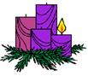

Dear Parents

**NOrthern Beaches Debating**

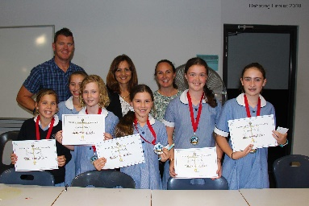Congratulations to our Stage 3 girls who placed as runners up in the Northern Beaches Catholic Schools Debating team. We are proud of their achievements. For many of them it was only their second or third debate under competition conditions.

**YEAR 6 FUN DAY**

Year 6 held their annual ‘Fun Day’ today.  They hosted games and activities for the rest of the school.  The aim of the day was to raise money for the Year 6 gift to the school community.

**Good Sam Day: Giving and Gratitude—Thursday 6 December**

*Giving*—thank you to all families who have already donated hamper items and gifts for our *‘Vinnies Christmas Hamper Appeal’*. The final day for donations will be tomorrow **Thursday 6 December**.

*Gratitude*—on Thursday during class time, students will be invited to contribute to their class’ Gratitude Tree. These trees will be displayed in the office windows for the remainder of the year. Students are invited to wear “A Touch of Christmas” on **Thursday 6 December**.

**CHRISTMAS CAROLS 6:00PM to 7:00PM 12 December**

Our children are pleased to present a beautiful evening of carols due to begin at 6:00pm sharp in St Cecilia’s Church. The children are asked to wear majority red, green or white clothing and enclosed shoes for protection in the confined space. They are welcome to wear tinsel or decorative ribbons in their hair. Costumes will be supplied by the school for the children who will be playing the Nativity characters. These children will need to wear white or light clothing underneath their costume. On the night of the carols, Nativity characters will be required to arrive at 5.30pm and meet in the Year 3 classroom to change into their costumes. All other students are to arrive at 5.45pm and meet their teacher in their classroom prior to the carols.

**STAFFING**

I want to thank Rachel Macri for her contribution to St Cecilia’s during 2018. She has been offered a graduate permanent position in the State system and sadly will be leaving us at the end of the year. We will now begin the recruitment process to replace her. At this stage classes and teaches will not be announced until 19 December once recruitment is finalised.

**FINAL ASSEMBLY AND ACADEMIIC Awards 17 December**

Our very special awards ceremony will commence at 2pm in the church on Monday 17 December. James Griffin our local State Member will be present at this assembly. Mr Griffin recently approved a grant of $18500 from the Community Building Grants program that will go toward building our shade structure over the basketball court. This assembly will be the perfect opportunity to thank Mr Griffin. At this final assembly for the year we will announce the recipients of the Core Value ‘Hope’ Award, the Academic Awards and the Patrick Anthony Award. All parents are invited to join us to celebrate the achievements of our students at this ceremony.

**Year 6 GRADUATION 14 December**

On Friday 14 December Year 6 will celebrate their Graduation with a very special Mass commencing at 1.45pm in the church. As our Year 6 graduating students celebrate the end of their primary schooling they celebrate a journey that began seven years ago with their first day in kindy.   A journey that has provided them with countless experiences and opportunities to learn, grow and mature.  They are well prepared and ready to journey onto their selected high schools assured that they have the skills and independence needed to be successful. We wish them God’s blessings as they leave us and invite the entire school community to come along and celebrate this important milestone with us.

**OUR THANKSGIVING Liturgy 19 December**

Finally we will end the year with a Thanksgiving Liturgy on Wednesday 19 December at 10:30am. At this celebration we give thanks for the past year and farewell departing students, families, staff and outgoing Parent Network members. We will also announce the 2019 School Captains, Liturgy Captains, Library Captains, Colour House Captains, Music and Environment Captains. At the conclusion of Mass at approximately 12 midday parents may collect their children to picnic with other families and friends or to get away early if leaving Sydney for the holidays. Please note there will be supervision at school until 3.15pm.

**School Reports**

End of year academic reports will be emailed after the Christmas Concert next Wednesday 12 December. End of year parent/teacher interviews are optional and primarily for any parent concerned about their child’s report. Please do not book an interview simply to thank teachers. A note addressing your gratitude would be very much appreciated instead. The procedure for booking appointments will be emailed out with the reports along with the student class requisite list for 2019. Please note this year you again have the option of ordering your child’s requisites on line from Humphries.

In Omnibus Glorificetur Deus

In all things may God be Glorified.



Fran Taylor

**Principal**

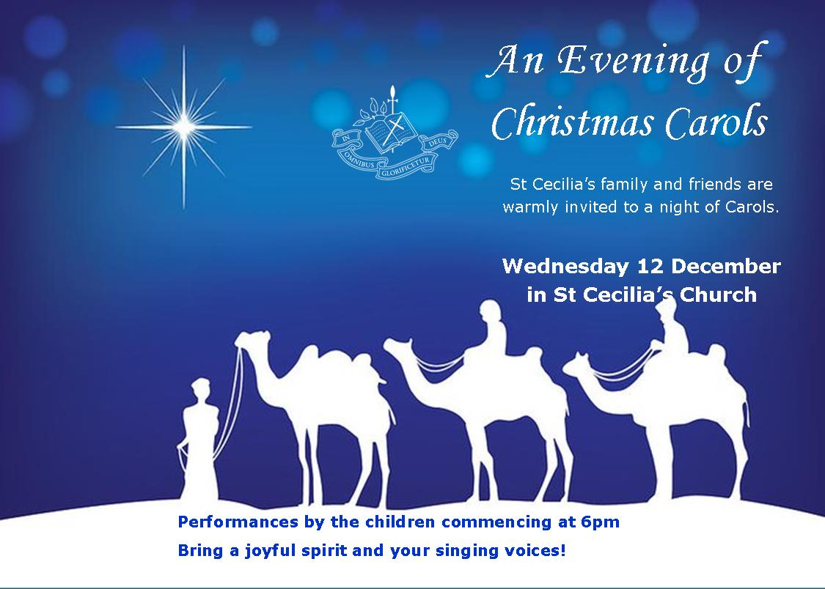

**Religious Education**

**CHRISTMAS HAMPERS**

We are excited, as a community, to continue one of our longstanding traditions by preparing to donate goods and gifts to the St Vincent de Paul Society.

A reminder that donated **goods** are due to your child’s classroom by **Thursday 6th December** to coincide with our *Good Sam Day: Giving and Gratitude.*

Donated **gifts** are also due to **Nikki Delrennie** via the school office.

There are still a few spots to fill for assembling and/or transporting the Hampers. Please **go to the ‘SignUpGenius’ page.**

<https://www.signupgenius.com/go/30E0949AAAE2CA6F94-vinnies>

Thank you for your generosity and thoughtfulness in this Advent Season.

**HEAVEN ON EARTH—PARENT PRAYER AND REFLECTION MORNING**

In order to deliver faith formation opportunities that cater to the current needs of our parent community, we ask that you take a few minutes to complete the following questionnaire. Your feedback will help inform future planning around Heaven on Earth or other faith formation opportunities.

[**https://goo.gl/forms/tSnHlpbb0Sj1utcl2**](https://goo.gl/forms/tSnHlpbb0Sj1utcl2)

**UPCOMING LITURGICAL CELEBRTIONS**

* Year 6 Graduation Mass—Friday 14December, 1:45pm
* Thanksgiving Liturgy—Wednesday 19 December, 10:30am

All welcome!

**PARISH MASS**

On **Wednesday 5 December, KB** attended our Parish Mass. Thank you to all family members who joined us for this Eucharistic celebration.

**KW** will attend Parish Mass on **Wednesday 12 December** at **9am.** This will be the final Wednesday Parish Mass our students will attend this year.

**ADVENT/CHRISTMAS—RELIGIOUS EDUCATION**

Over the next three weeks all classes will be focusing on Advent leading to Christmas. The liturgical season of **Advent** will be explored as a time of **waiting and preparation for the celebration of the coming of the Messiah**. **The people of the Old Testament waited, Joseph and Mary waited and so we too wait in anticipation.**

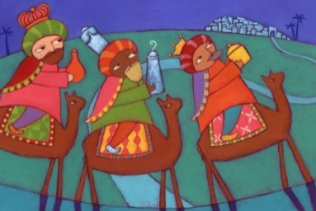***Stage 1—Year 1***

**For Advent:**

The students will explore scriptural stories from Luke’s Gospel which describe events leading to Jesus’ birth Jesus and will reflect upon how they wait for Jesus in their own lives. They will learn that as we wait for the celebration of Jesus’ entry into our world, we also await with Jesus a time when there is peace and love and no-one is hungry or disadvantaged.

**For Christmas:**

Children will explore and deepen their knowledge of key people and events described in the Infancy narratives of Matthew and Luke. They will explore the depth of meaning in these narratives e.g. what the different characters represent.

**SHARING THE MESSAGE OF CHRISTMAS**

In the rush and bustle of Christmas we may sometimes lose sight of the ‘reason for the season’. Click [here](http://www.scbdbb.catholic.edu.au/_uploads/rsfil/003095_cbbe.pdf) for some ways families can share the true meaning of Christmas from Janette Davidson, Family and Sacramental Minister

Catholic Community of North Harbour.

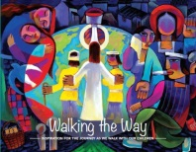**WALKING THE WAY**

Walking the Way is a school-based initiative in the Catholic Diocese of Broken Bay, designed to encourage parents in their sacred task of accompanying their children on their journey with God. There are four elements: Book & video / E-Bulletin / Parent gatherings / Annual retreat. Click here to view <http://walkingtheway.dbbcso.org/archive-2018-year-b.html> .

**School News**

**Leadership Day**

On Friday 7 December the students in Year 5 will be involved in a Leadership Day. During the day the students will explore the qualities of leaders and identify and discuss the leadership positions and responsibilities that will be available in 2019. The students will also begin writing their leadership speeches on this day.

The speeches will be presented to the children in Year 3 - 6 on Thursday, 13 December. After this all teachers and students in Year 2 to 5 who will be attending St Cecilia’s in 2019 will vote.

The Leadership positions for 2019 will then be announced at the Thanksgiving Liturgy, Wednesday 19 December 10:30am.

**WEEKLY AWARDS**

We congratulate this week’s Awards’ recipients.

|  |  |  |  |
| --- | --- | --- | --- |
|  | **Week 7** | **Hope Core Value** | **Merits** |
| **KB:** | Angus M | Madeleine R and Oliver D |
| **KW:** | Justine A | Miles M and Rufus M |
| **Yr 1B:** | Kingston S | Christopher C and Lucas C |
| **Yr 1W:** | Zachary B | Jessica O and Imogen H |
| **Yr 2B:** | Harrison LS | Neve M and Emily K |
| **Yr 2W:** | Hunter S | Xander C and Harrison L |
| **Yr 3:** | Oscar P and Harper V | Henry M, Lyla RD, Alessia Z and Danica P |
| **Yr 4:** | Harley B | Piper L and Riley M |
| **Yr 5/6** | Sophia N and Emma M | Sophie H, Emma W and Ruby S |

**UPCOMING DATES**

**December**

Thurs 6th Good Sam Day

Christmas Hamper donations due

Wear a ‘*Touch of Christmas’*

Drama concert

Fri 7th Yr 5 Leadership Day

Yr 6 Reflection Day

2.30pm Millie Smith pop up shop

Wed 12th Reports home

6pm Christmas Carols in the Church

Fri 14th 1.45pm Yr 6 Graduation Mass

Mon 17th 2pm Core Value & Academic Assembly

Wed 19th 10.30am Thanksgiving Liturgy

Wed 19th **Last day for students**

Thurs 20th SDD

Fri 21st SDD

**January 2019**

Wed 30th EMU and Best Start appointments

Thurs 31st Yrs 1 – 6 commence

Best Start Kinder appointments

**February**

Fri 1st Kinder 2019 commence

Tea and Tissues

Tues 5th 6pm Meet the Teacher

Thurs 7th 2.30pm Class Parent meeting

Fri 8th 9.30am Opening School Mass and Ceremony of Light

Thurs 14th Swimming Carnival

Tues 19th P&F Exec meeting

Fri 23rd Welcome Cocktail Party

**DRAMA**

‘Break a leg’ all those children performing in the Drama Christmas play on Thursday evening. Notes have been given out today with further details.

‘Lines’ are still very uncertain right across the board so a big concerted effort is needed tonight to rectify this. Help from parents or older siblings would be very much appreciated.

This is our final week for drama so a big thank you to all for your support and a happy and safe holiday to all. Happy Christmas and New Year.

*Trish Collier, Stageworks Drama Teacher*

**Parent Network News**

* **Parent’s Christmas Party**

A big thank you to everyone who attended the school Christmas party! It was a great night for all, with lovely food, fun and fabulous festivities.

* **St. Cecilia’s 90th Anniversary Celebrations**

St Cecilia’s School was founded by the Good Samaritan Sisters in 1929 and we will be celebrating our 90th anniversary next year. *If you have any ideas for how we could celebrate, email Robyn Wunder who will be collating plans over the coming weeks*[***robyn@thewunders.net***](mailto:robyn@thewunders.net)***.***

* **Millie Smith Second Hand Uniform Shop**

Thank you for your donations of pre-loved school uniforms throughout the year.Our last Millie Smith Uniform Shop sale will be this Friday 7December, 2:30-3:30pm. Remember to pay by cash or Qkr.

* **Heaven on Earth - Parent Survey**

Heaven on Earth is offered to parents and parishioners to take some time out of their busy schedules to reflect on their own and their family’s faith life. The sessions have been held once a term, both during the day or in the evenings. Guest speakers have been invited to facilitate topics such as: The Gift of Gratitude, The Gift of Courage, The Gift of Wisdom, The Gift of Compassion, The Gift of Mercy, Walking Justly, Walking the Way, River of Mercy, Christmas: Peace on Earth of going to pieces and An Advent Journey.

The program began in 2014 and we are now reviewing it. We invite you to answer the following questions. Your feedback will help us plan for the future of Heaven on Earth. It should take no more than 10mins of your time.

Questionnaire--<https://goo.gl/forms/HRRUcInaNA1fONb43>

With thanks from, Majella Brady (Heaven on Earth Coordinator and mum) and Nikki Delrennie (St Cecilia’s Religious Education Coordinator)

* **Welcome Cocktail Party**

Save the date for another lovely social night to welcome the new families to our wonderful school – Saturday 23rd February.

**Volunteer Corner**

1. **Christmas Hampers**

Please help with Christmas Hampers **this Friday** to sort, pack and wrap the Vinnies Christmas Hampers in the school hall on Friday 7 December. You can sign up for 1 of 4 tasks which take no more than a couple of hours.

Please s*ign-up:*[*https://www.signupgenius.com/go/30E0949AAAE2CA6F94-vinnies*](https://www.signupgenius.com/go/30E0949AAAE2CA6F94-vinnies)

1. **Millie Smith Second Hand Uniform Shop**

Our last Millie Smith Uniform Shop will be this Friday 7th December, 2.30-3.30pm - TWO VOLUNTEERS ARE NEEDED.

**Sign up:**[**https://www.signupgenius.com/go/30e0949aaae2ca6f94-mille**](https://www.signupgenius.com/go/30e0949aaae2ca6f94-mille)

**PARENT INFORMATION GUIDE:** Click [here](http://www.scbdbb.catholic.edu.au/_uploads/ppage/files/2018%20%20Parent%20Information%20Guide(2).pdf) for the 2018 booklet.

**ANGELS AND SHEPHERDS AND OTHERS WANTED FOR THE CHRISTMAS FAMILY VIGIL**

Children (Kindergarten 2018 and older) are invited to participate in a Christmas Liturgy at 5.30pm Christmas Eve at St Cecilia’s.

We also require some older children for speaking parts. Any assistance from parents would be greatly appreciated.

We will have rehearsals on 16 December and 23 December both at 10am after 9am Mass

If your child is interested Please contact Bryanne ASAP [bryannecrabb@gmail.com](mailto:bryannecrabb@gmail.com)



The roster can be found through the school website under the School Community/Volunteering tab or click [here](http://www.signupgenius.com/go/30e0949aaae2ca6f94-stcecilias9) .

Upcoming Roster

Fri 7 Dec: Susie Warren and **1 Volunteer required**

Mon 10 Dec: Crystal Redpath

Wed 12 Dec: **2 Volunteers required**

Fri 14 Dec: Ria Deveza and Rob Pyne

**TENNIS 2019**

Hi Tennis enthusiasts

2018 has been a great year with the children really enjoying their tennis, some early morning exercise and also some awesome and exciting improvements.

For 2019 I will be offering 3 mornings, Monday, Wednesday and Friday 7.45-8.30am so please email me [bryannecrabb@gmail.com](mailto:bryannecrabb@gmail.com) or call me on 0403063013 to express interest. It will once again be on a first come basis and spots do fill quickly. Racquets are provided or you may bring your own

Also if you are planning on supporting the Aussie tennis players through the Summer holidays and are going to either Brisbane, Sydney or The Australian Open please let me know as Jaymon will be there coaching the Davis Cup players and there could be opportunities to meet them or at least get inside notes on where and when they are practising.

Thanks

*Bryanne*

**Community News**

**VACATION CARE**

Northern Beaches Council operates a very successful vacation care program for primary school aged children across the whole of the Northern Beaches. In the Summer school holidays we will have centres open at Cromer, Forestville, North Curl Curl and also at Manly Vale Community Centre.

With the December/January school holidays approaching fast, we have just released the holiday program on our website, with the Summer 2018/19 brochure containing lots of activities and ideas to keep children occupied.  Copies of the brochure are available at the school or via the council website:  [Northern Beaches Council Vacation Care](https://www.northernbeaches.nsw.gov.au/services/children/child-care/vacation-care)

**Thank You to our Sponsors**

**Our Gold Sponsors are . . . . .** .



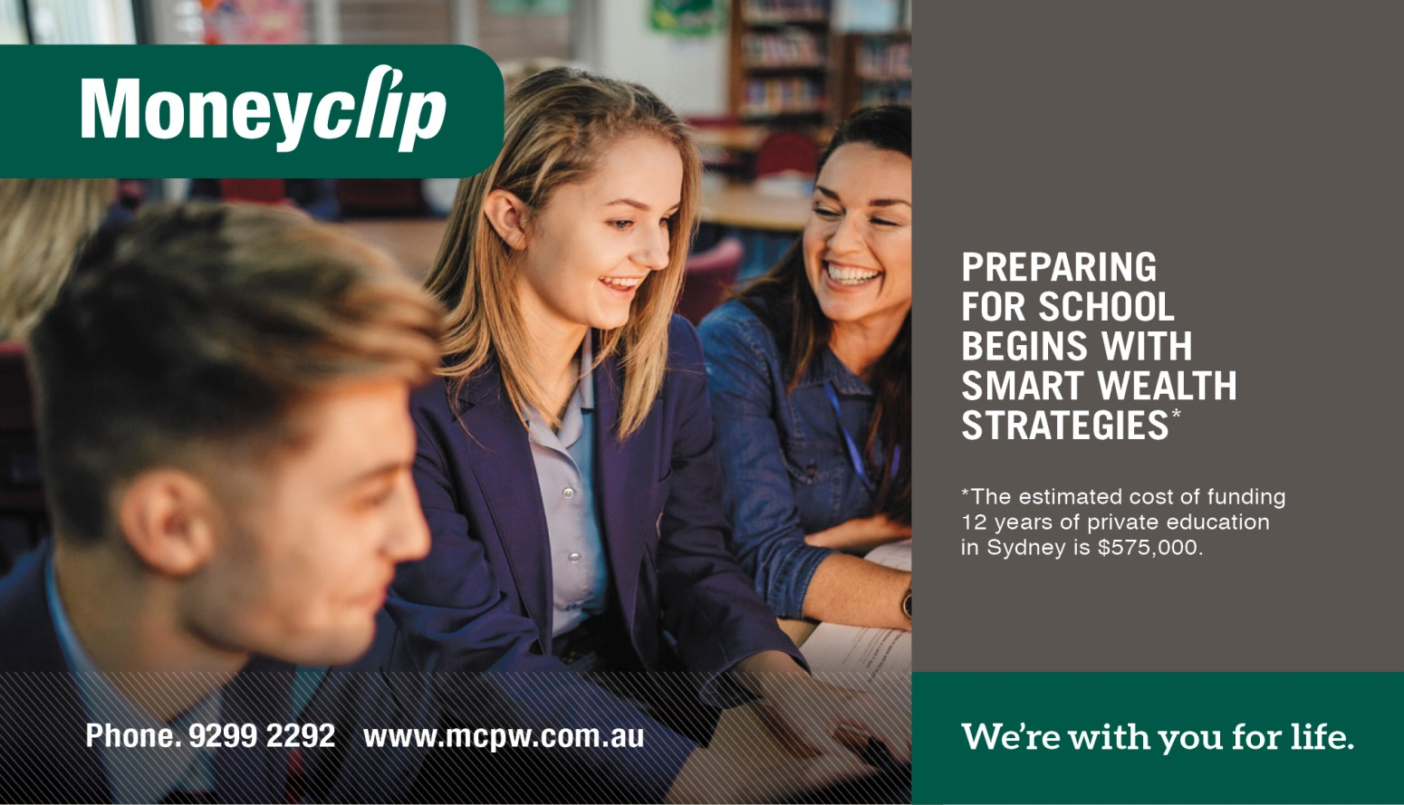



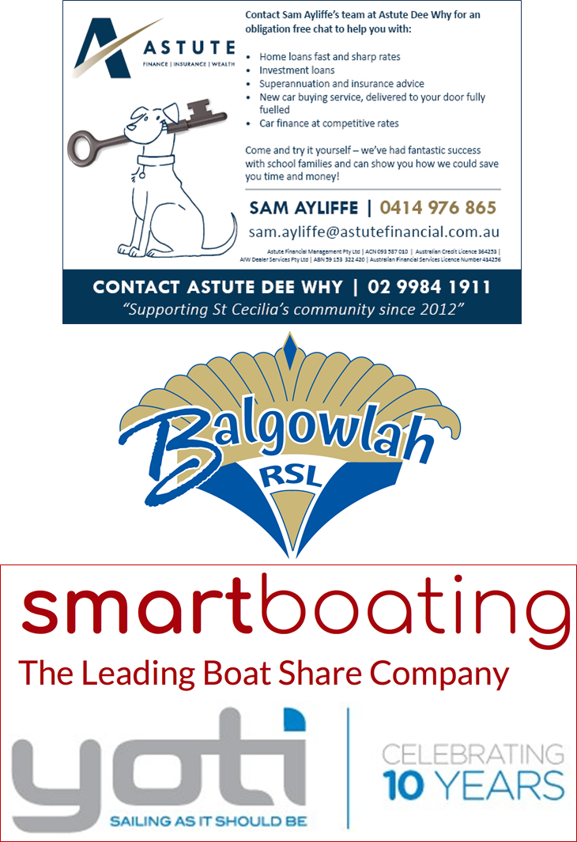

**Our Silver Sponsors are . . . . .**

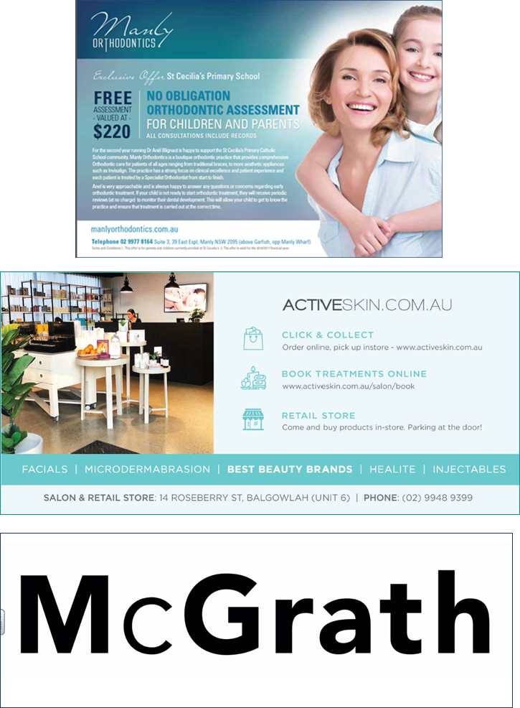





**Our Bronze Sponsors are . . . . .**

