St Cecilia’s Catholic School Balgowlah
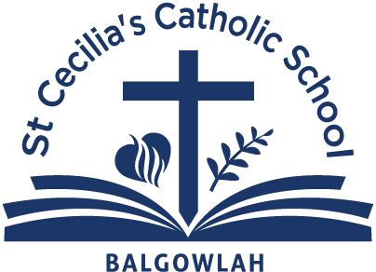
Enrolment Checklist
Form to be submitted with Enrolment Form and Documents
Student Name

Enrolment for Grade  eg Kinder, Year 5 |  |  |  | Year commencing  eg 2022
Office use only |  |  | Please tick to ensure all relevant documents are provided with your Enrolment application
 |  |  | - Enrolment Form
 |  |  | - Birth Certificate
 |  |  | - Sacramental Certificates to date
 |  |  | - Immunisation History Statement – online version
 |  |  | If applicable
 |  |  | - Passport, visa, citizenship documentation
 |  |  | - Most recent previous school reports and external test results
 |  |  | - Current Family Court Orders
 |  |  | - Relevant medical and / or special needs information
 |  |  | - Reports of assessments your child has received for speech, hearing. occupational therapy or cognitive (IQ)
Please Note – originals will need to be produced during the
enrolment interview

OFFICE USE ONLY
Interview date and time:
Comments:

